|  |
| --- |
| **Argentis Consulting** |
| **Apparel & Footwear** |
| Link Project Critical Path Activity to Production JOB |



**www.sapapparel.com**

Link Project Critical Path Activity to Production JOB

It is possible to track a production activity in the critical path. This is by relating the two activities. If the production task is delayed the critical path gets updated automatically.

Important: make sure you don’t have the allow overlapping activities active in the setup.

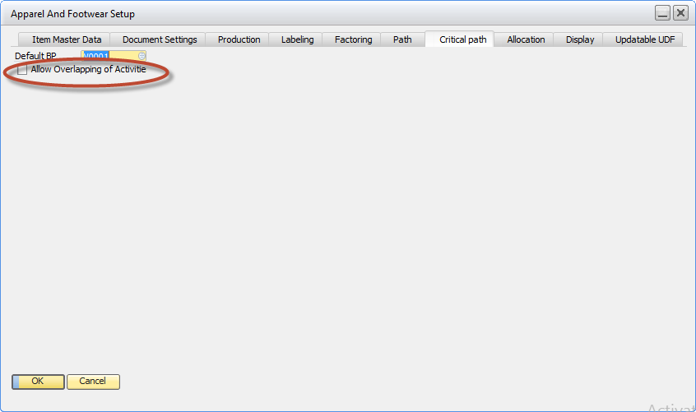

Create a style with a workflow, then create a project

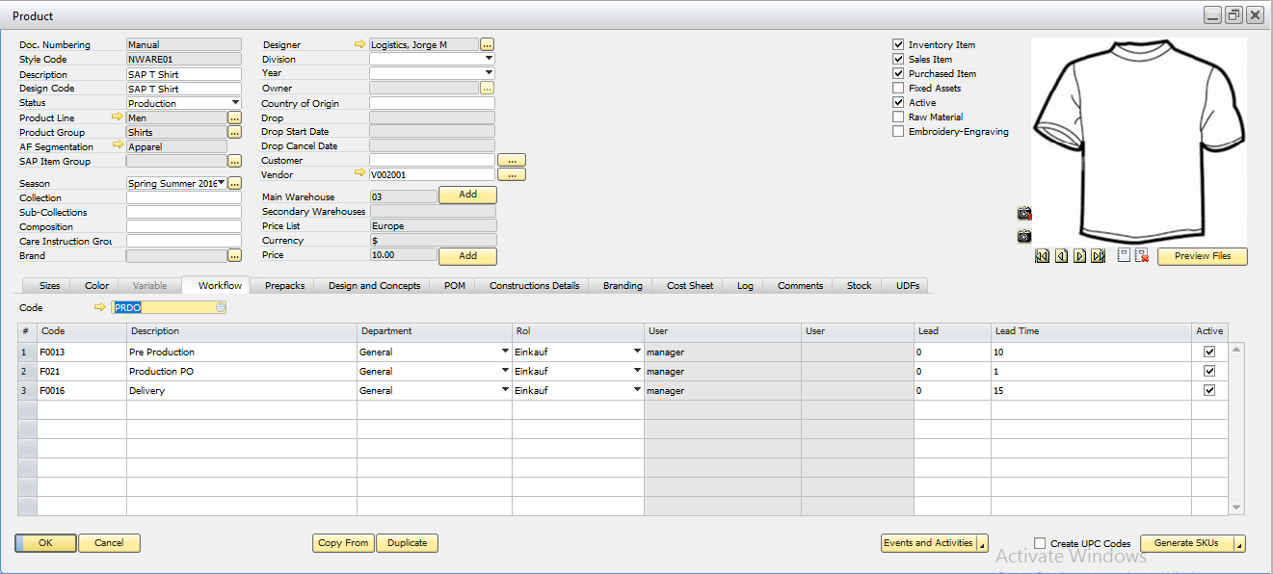

Assign the JOB number to the critical path activity

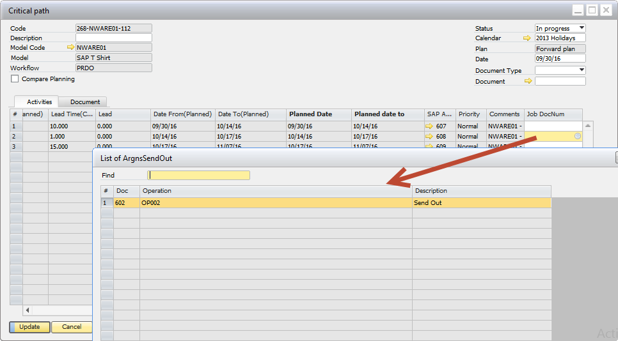

The activity shows in the production JOB

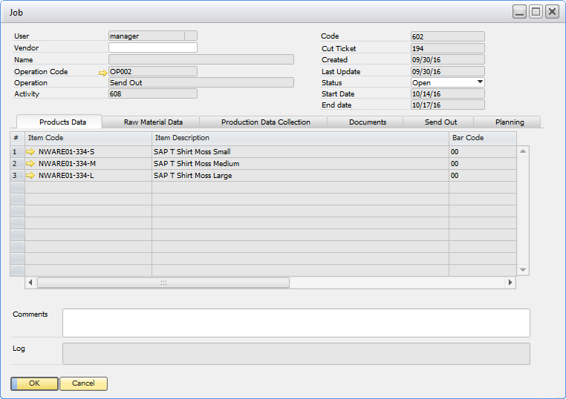

If the planning in production is updated. The critical activity in the project is also updated

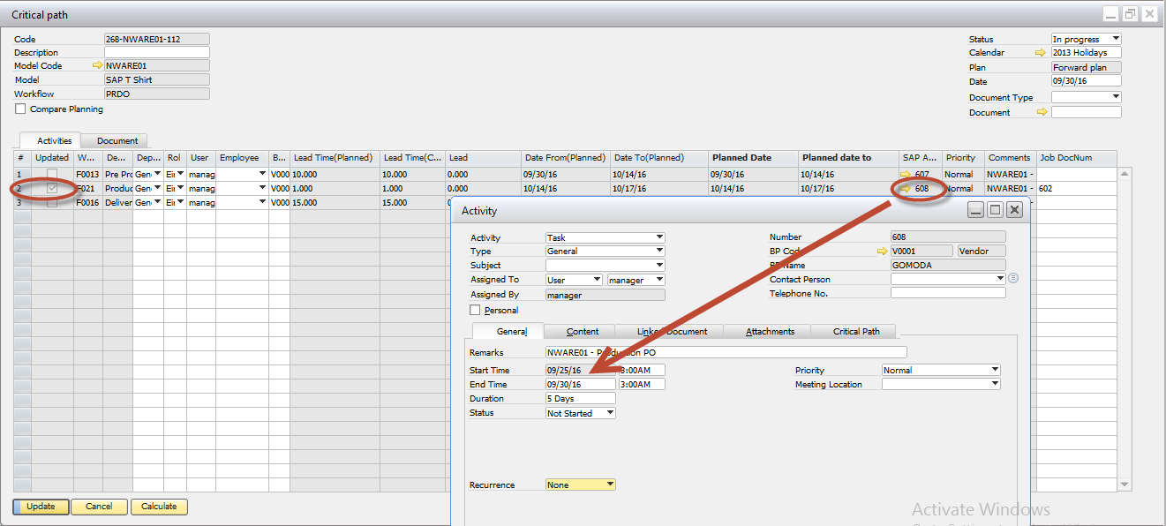

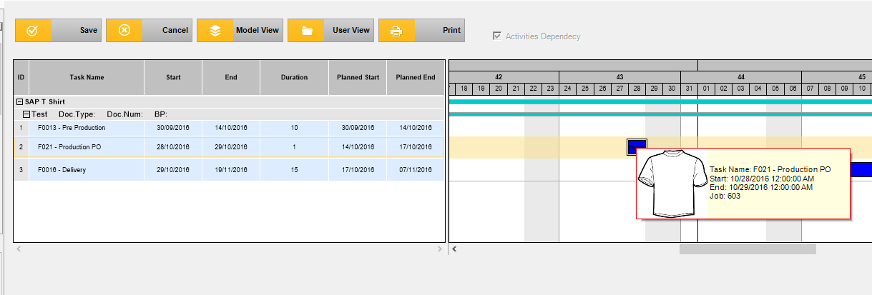



**www.argentisconsulting.com**

**Argentis Consulting** is dedicated to the development, distribution and support of recognized certified solutions for SAP Business One, as an SSP (Software Solution Provider) with a Gold Partner status.

**CONTACT INFORMATION**

|  |  |
| --- | --- |
| **USA**  9744 NW 45th Lane  Doral, FL 33178  info@argentisconsulting.com | **ARGENTINA**  Ávila y Zarate 2048  Cerro de la Rosas, Córdoba,  CP 5009  Córdoba - Argentina  info@argentisconsulting.com |
| **CARIBEAN**  City View Plaza – Suite 301  48 Road 165  Guaynabo, PR. 00968  Puerto Rico  caribe@argentisconsulting.com | **SPAIN**  C/ Juan Bravo N° 3 A 28006  Phone: (+34) 91 123 7263  Madrid - Spain  info@argentisconsulting.com |